Markus Dezelak
CSC500 Intro To Programming
Module 1
12/9/2025

Github -- https://github.com/theG3RMAN

Part 1

Pseudocode

START
PROMPT enter first number
STORE as num1

PROMPT second number
STORE as num2

CALCULATE sum = num1 + num2
CALCULATE difference = num1 - num2

DISPLAY addition sum
DISPLAY subtraction sum
END

num1 = float(input(“Enter the first number: “))
num2 = float(input(“Enter the second number:”))

additionsum = num1 + num2
subtractionsum = num – num2
print("The addition of the two numbers is:", additionsum)
print("The subtraction of the two numbers is:", subtractionsum)
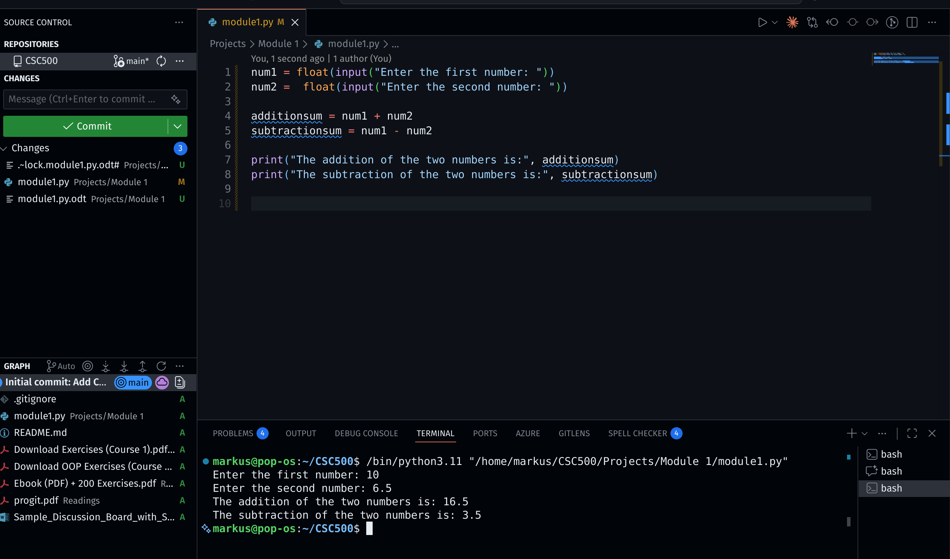

Part 2

Pseudocode

START
PROMPT enter first number
STORE as num1

PROMPT second number
STORE as num2

CALCULATE multiplication = num1 + num2
CALCULATE division = num1 - num2

DISPLAY Multiplication sum
DISPLAY Division sum
END

num1 = float(input(“Enter the first number: “))
num2 = float(input(“Enter the second number:”))

multiplysum= num1 * num2
dividesum = num / num2
print("The multiplication of the two numbers is:", multiplysum)
print("The division of the two numbers is:", dividesum)

